$400 Hong Kong Dollar Ingredients

* Quick Cook Oat Meal 1kg
* Brought From Best Mart 360 ~ $18
* Total Price: $18

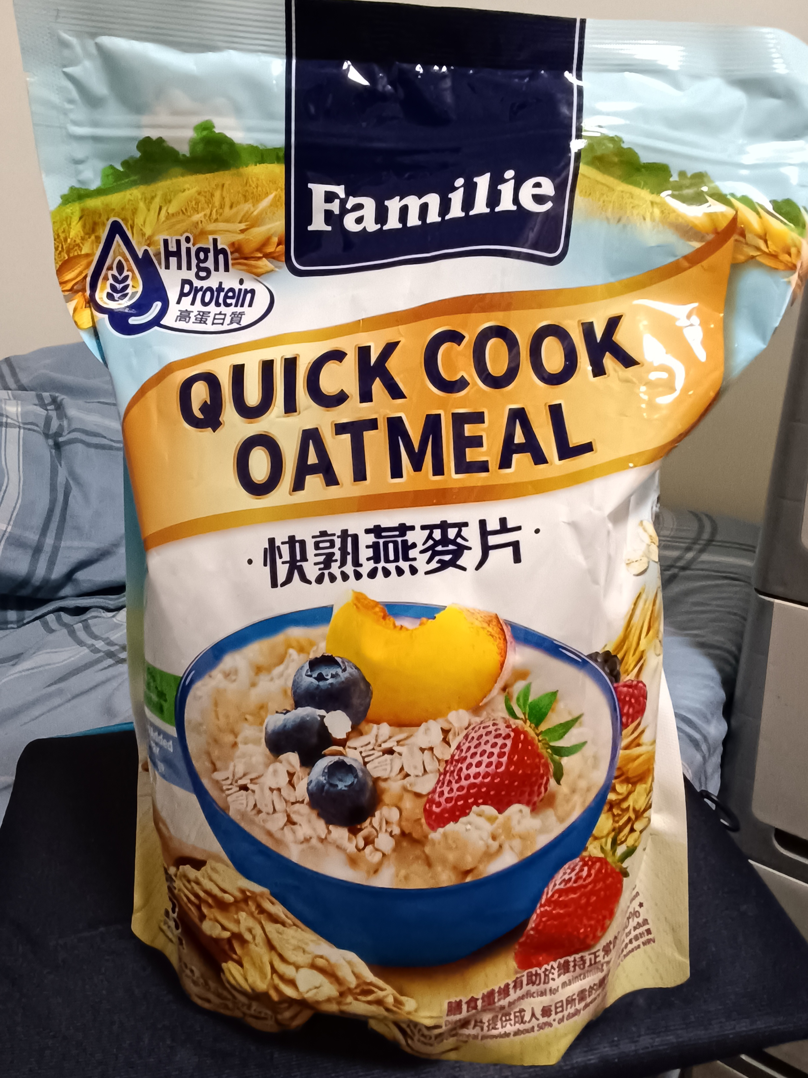

* Chicken Chops X 13
* Brought From Market ~ $11
* Total Price: $143

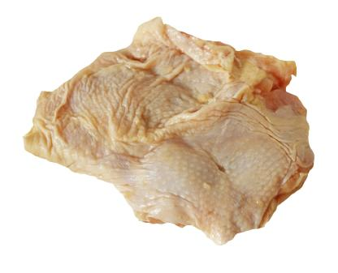

* Rice 5kg
* Brought From Best Mart 360 ~ $49 (Member Price)
* Total Price: $49

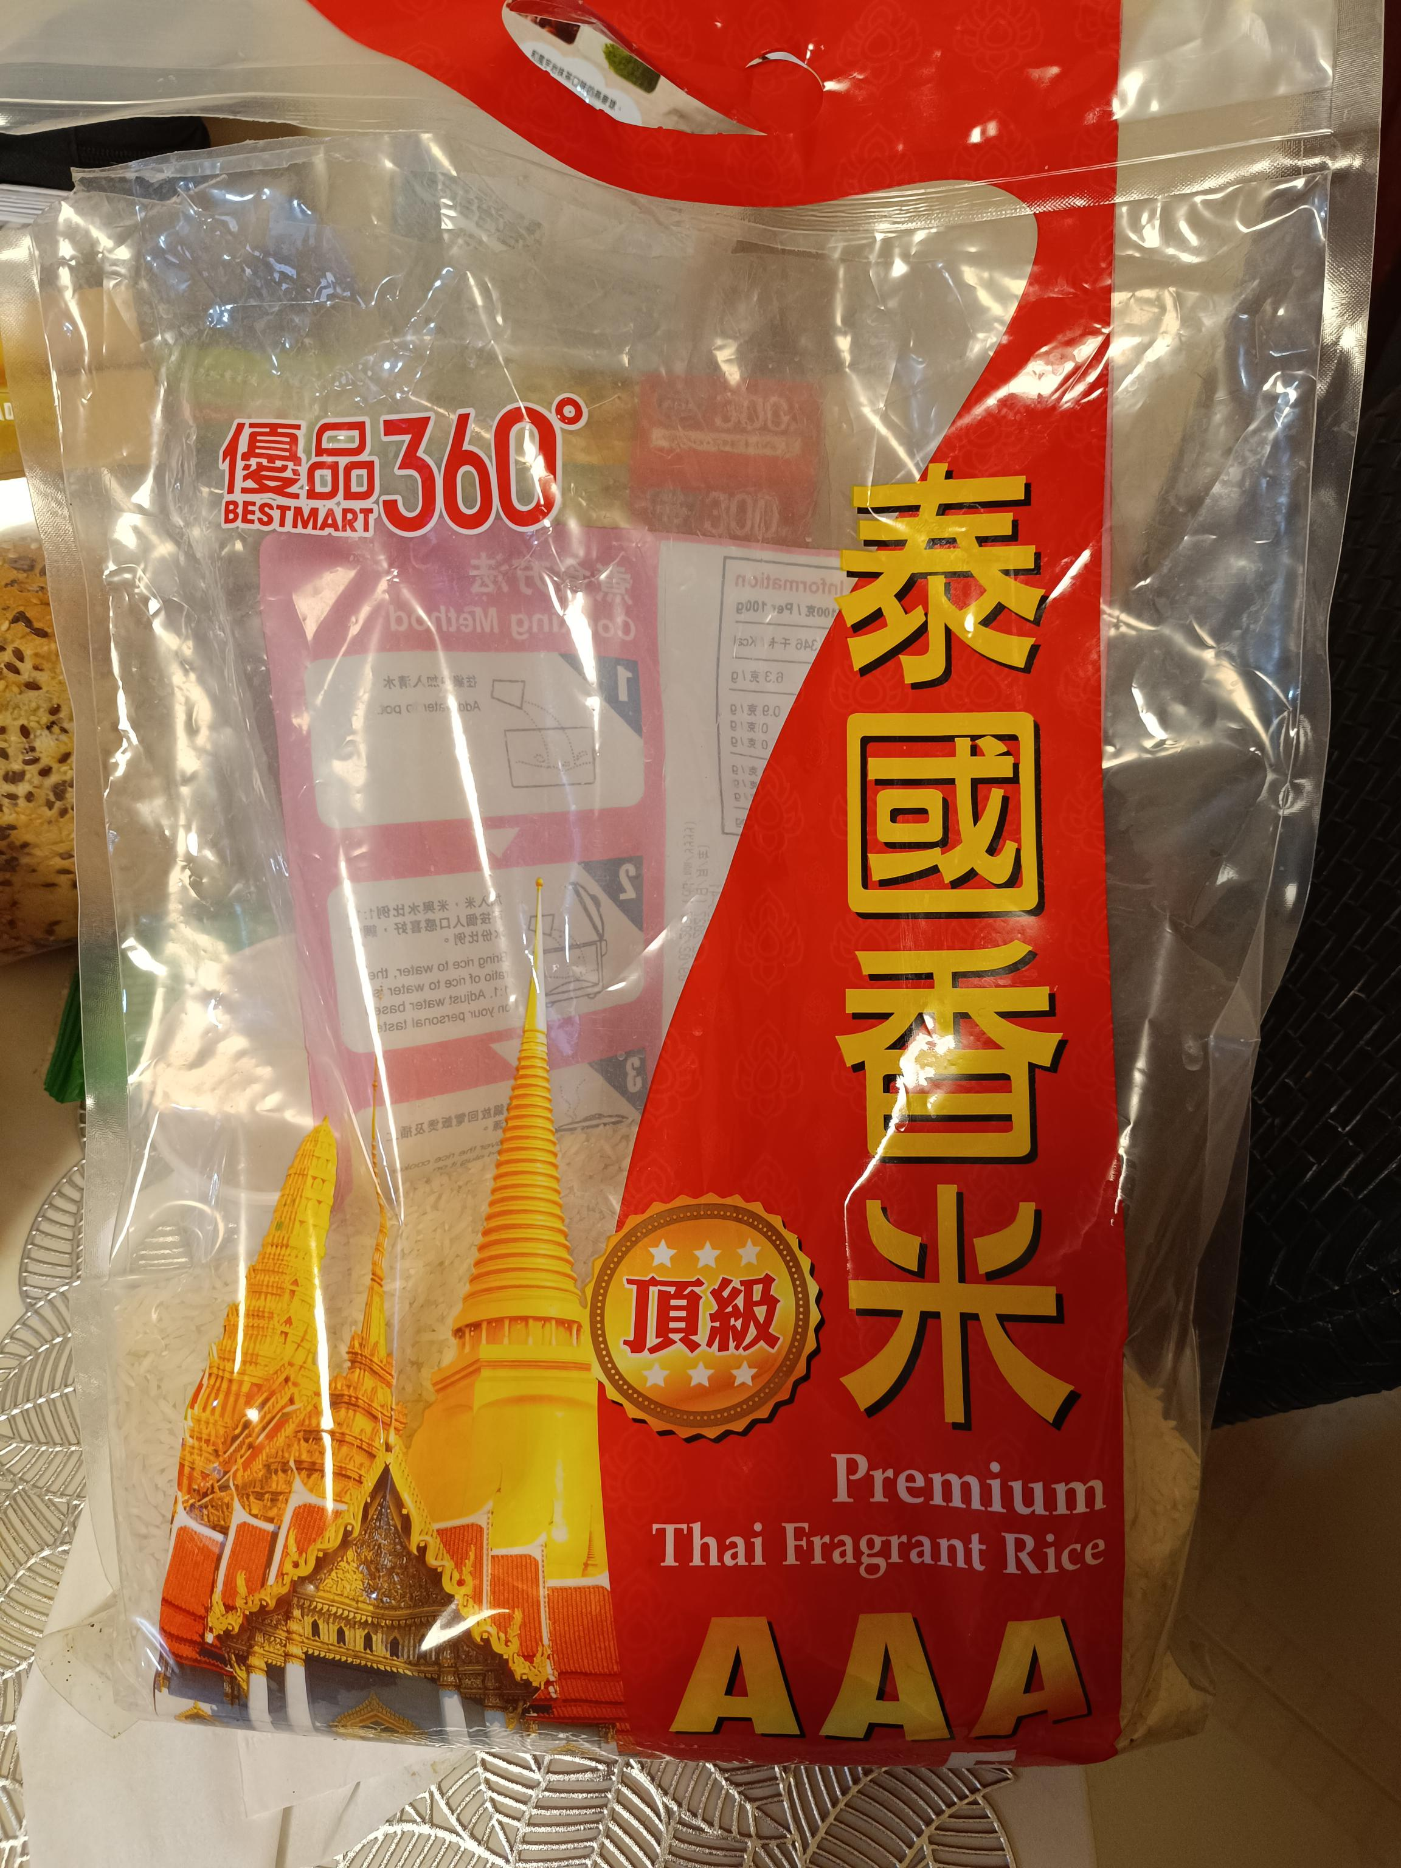

* Vegetables (any vegetables) 5kg
* Brought From Market ~ 1kg ~ $12
* Total Price: $60

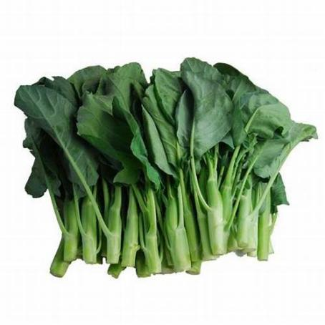

* Meadows瑪利餅 350GM X 3
* Brought From Welcome Supermarket ~ 1 packet ~ $22
* Total Price: $66

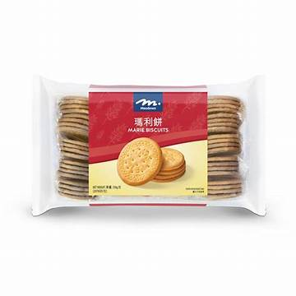

* Devondale Skimmed Milk X 7
* Brought From ParknShop Supermarket ~ $17.9 For 2 / $19.9 For 1
* Total Price: $73.6

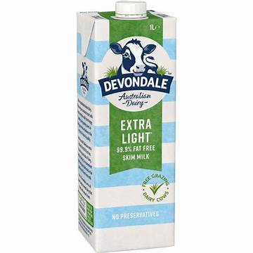

***Total Price: $409.6 (Last Updated: 16th May 2025)***

**Meals - 3 meals Plus Snacks**

**(Breakfast, Lunch, Dinner, Snacks)**

* Breakfast Oat Meal
  + Oat 8 tea spoon (equivalent to 40 gram)
  + either salt / sugar / Soy sauces
  + Water (500ml)
* Morning Snacks
  + Marie Biscult 1 packet
* Lunch
  + Meat Raw ~ 81 gram
  + Vegetable ~ 83.33 gram
  + Rice ~ 125 gram
    - Add water to the pot
    - Add meat (Marinated with salt) and vegetable when the water is fully boiled.
    - Wash the rice and steam the rice.
    - Served.
* Afternoon Snacks
  + Marie Biscult 1 packet
* Dinner
  + Meat Raw ~ 81 gram
  + Vegetable ~ 83.33 gram
  + Rice ~ 125 gram
    - Add water to the pot
    - Add meat (Marinated with salt) and vegetable when the water is fully boiled.
    - Wash the rice and steam the rice.
    - Served.
* Before Bed
  + One cup of skimmed milk (approximate 233 ml)